The Enviróza School Programme.
A Successful Example of the project using Citizen Science approach.

Elena Bradiaková
Slovak Environment Agency
Department of Analyses, Environmental Assessment and Environmental Services
Tajovského 28, 975 90 Banská Bystrica
elena.bradiakova@sazp.sk
+421 48 4374 164

Abstract
Enviróza is a citizen science project intended for primary and secondary schools. It is realised by the Slovak Environment Agency. It was designed as a school activity of the project financed by the EU Cohesion Fund and was launched at the start of the 2013/2014 school year. Enviróza has been played in the form of an outdoor game, has its own rules and didactics. Its main practical role is to update information about selected contaminated sites registered in the Information system of Contaminated Sites in Slovakia.
Keywords
Citizen Science, contaminated sites, environmental education, game, primary and secondary schools, pupils, rules, school programme, students, teachers, trips, web portal

Glossary
Environmental burden – the term has been used in the Slovak environmental legal regulations in the meaning of contaminated site
Potencial environmental burden – the term has been used in the Slovak environmental acts in the meaning of potentially contaminated site

Abbreviations/Acronyms
CS – contaminated site
ISCS – Information System of Contaminated Sites, https://envirozataze.enviroportal.sk/
SEA – Slovak Environment Agency

Author and co‐author of the school programme
Jana Šimonovičová
Slovak Environment Agency
jana.simonovicova@sazp.sk
Jaromír Helma
Slovak Environment Agency
jaromir.helma@sazp.sk
+421 48 4374 165

The case study

Enviróza (Envirosis) is a school programme and outdoor game designed to gather and spread information on contaminated sites in Slovakia.
Intended for primary and secondary schools, the programme is implemented through the website www.enviroza.sk (Fig. 1). The participants (teachers and pupils) seek out and identify contaminated sites, publish their data online and score points for doing so. Through accompanying competitions they also inform the public about this issue.
Enviróza is categorised as a citizen science programme; its practical role is to update information about selected contaminated sites registered in the Information system of Contaminated Sites (ISCS) and to identify new sites (known as school-identified sites) that display signs of serious contamination. The information gathered by the participants is further processed by Slovak Environment Agency (SEA) staff, integrated into the ISCS and thus made available to state authorities as well as the professional and lay public.
Enviróza’s educational goal is for participants to gain information about existing contaminated sites and the state of their own environment based on first-hand observations in the field. In the process, pupils and students develop their skills at orientation with maps and navigational tools; they learn to work with information, use information/communication technology and work as a team, as well as think critically and express their own opinions. The programme provides the teacher with an experiential learning tool for environmental education and incorporating the issue of contaminated sites into lessons of many other school subjects including mathematics, information technology, biology, chemistry, Slovak, art and civics. The materials include a teacher’s handbook and worksheets with 50 activities, but the chief teaching aid is the programme website itself.
Enviróza was part of the project Education and public awareness as a support in contaminated sites remediation in the Slovak Republic, which was financed by the EU Cohesion Fund as part of the Operational Programme Environment (2007–2013). The programme was launched at the start of the 2013/2014 school year, under the auspices of the Ministry of Environment of the Slovak Republic.

list of contaminated sites

Using the Information system of Contaminated Sites (ISCS), a list of 501 contaminated sites distributed throughout Slovakia has been created for the purposes of the programme (game). Safety was the chief selection criterion, which eliminated certain groups and classes of sites completely. The final list consisted of 192 sites from Register A (potentially contaminated sites), 22 from Register B (confirmed contaminated sites) and 214 from Register C (remediated, reclaimed contaminated sites), as well as 50 categorized as both A and C, and 23 categorized as both B and C.

Through active participation in the Enviróza school programme, pupils and students help to address the issue of contaminated sites in Slovakia in the following ways:
- The information they collect by seeking out and identifying contaminated sites is further processed and utilised by SEA staff and state authorities.
- The identification (ID) forms are linked to concrete contamination sites/contaminated sites in the Information system of Contaminated Sites (ISCS, http://envirozataze.enviroportal.sk/), and thus made available to the professional and lay public.
- They can point out new sites not yet listed in the ISCS and become their annotators, helping to identify as-yet-unrecorded cases of contaminated sites in Slovakia.
- As part of the informational competitions, they help to spread information and raise public awareness about the issue of CS. This preventive action contributes not only to environmental conservation but possibly also to the participants’ own health.

results

Enviróza was launched at the start of the 2013/2014 school year, during which 71 schools and 440 participants (teachers, pupils and students) took part in the programme. Together the teams mapped 120 contaminated sites, of which 95 were from the ISCS and 25 were school-identified.
In its second school year 2014/2015 91 schools from across Slovakia were registered in the Enviróza programme. Together the teams mapped 116 contaminated sites, of which 53 were school-identified.
93 teams mapped contaminated sites in its 3rd year during the 2015/2016 school year.

Further Reading
Problematika environmentálnych záťaží na Slovensku [State of the Contaminated sites in Slovakia]. Slovak Environment Agency, 2010. ISBN 978-80-88850-98-4.
Management of Contaminated Sites in Slovakia. Slovak Environment Agency, 2015. ISBN 978-80-89503-39-1.
Štátny program sanácie environmentálnych záťaží (2010 – 2015) [The State Remediation Programme of Environmental Burdens (2010 – 2015)]. Ministry of Environment of the Slovak Republic, 2010.
Štátny program sanácie environmentálnych záťaží (2016 – 2021) [The State Remediation Programme of Environmental Burdens (2016 – 2021)]. Ministry of Environment of the Slovak Republic, 2016.
www.enviroza.sk
www.enviroportal.sk
ww.sazp.sk
http://www.sazp.sk/public/index/go.php?id=2222
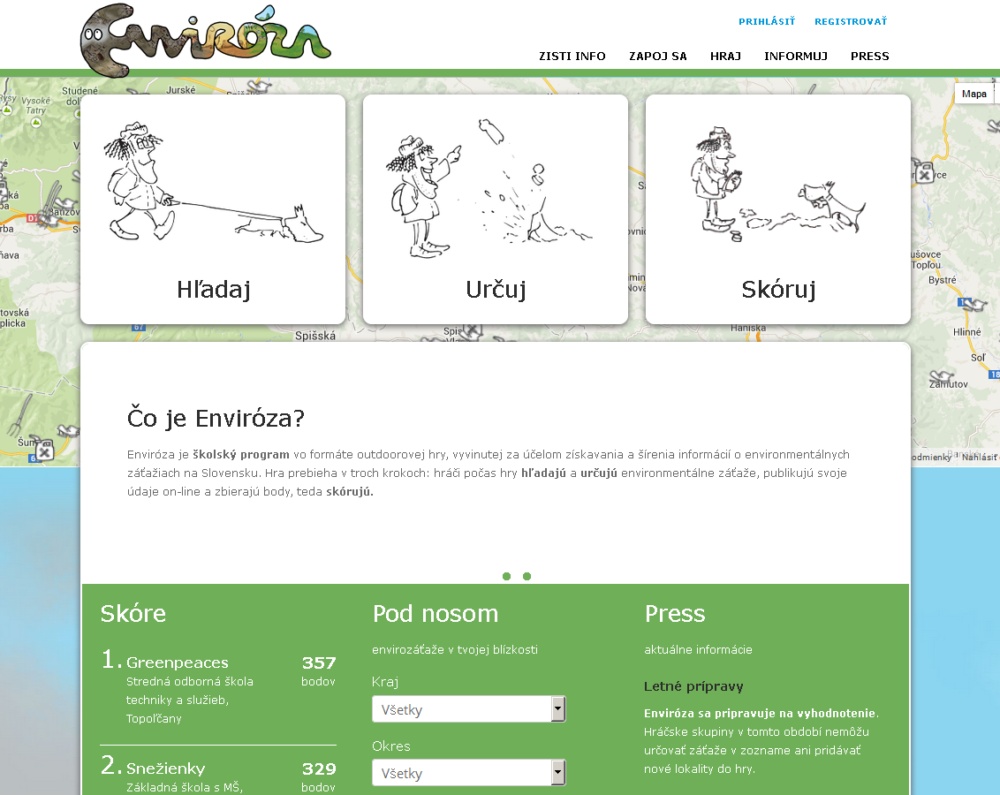

Fig. 1 Homepage of the school programme Enviróza website

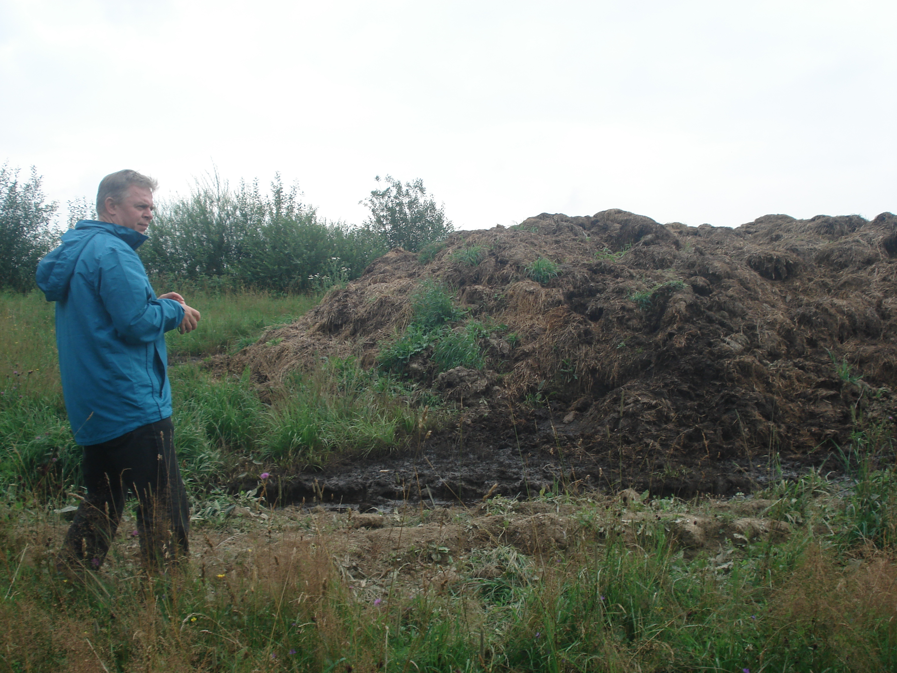

Fig. 2 A total of 25 new sites were added by schools. After they were mapped, field inspection and evaluation of the school-identified sites for the purposes of their classification in the ISCS was carried out by Jaromír Helma, contaminateds sites expert (SEA) in July and August 2014.

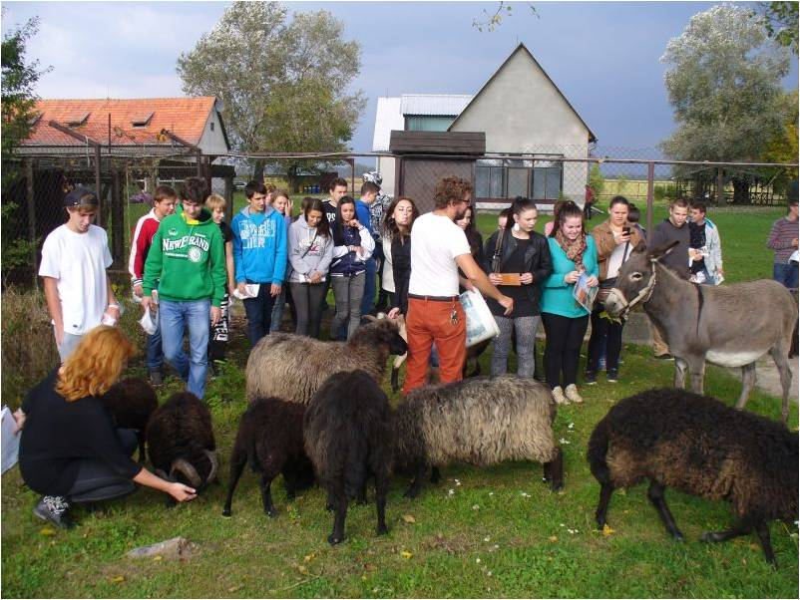

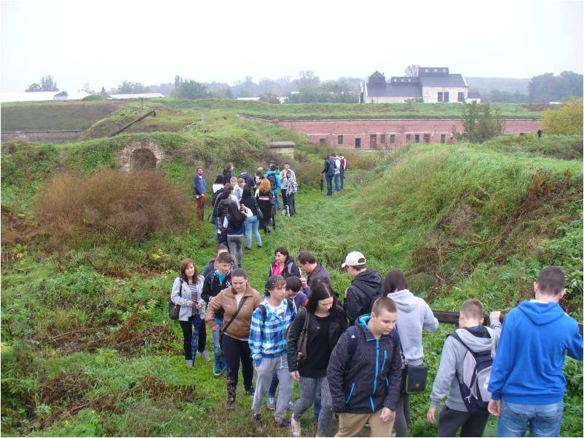

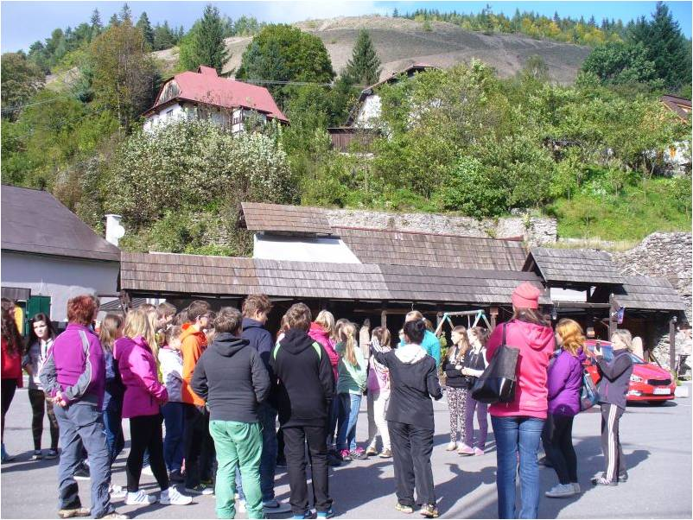

Fig. 3, 4, 5
The teams that placed first, second and third were rewarded with a class field trip to an environmental contamination site. Every participant received a T-shirt with the Enviróza logo as a small gift. Organised by the Banská Bystrica company MEEN, in cooperation with members of the Awareness project team, the all-day field trips were made in September and October 2014

Author of photos: Archive of SEA

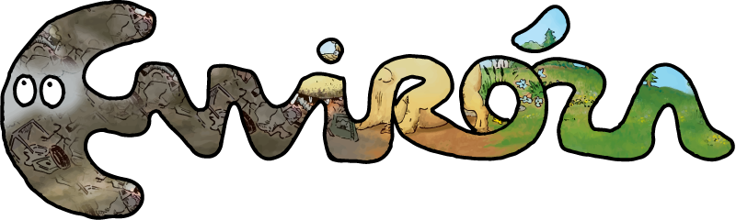

Fig. 6 The Enviróza logo (Author: Ladislav Vojtuš)

